Структура Базы данных.
Таблица Purchase:
Название поля | Тип поля
Id | AutoField
PurchaseOrder | CharField
RegistryNumber | CharField
ProcurementMethod | CharField
PurchaseName | CharField
AuctionSubject | CharField
PurchaseIdentificationCode | CharField
LotNumber | IntegerField
LotName | CharField
InitialMaxContractPrice | FloatField
Currency | CharField
InitialMaxContractPriceInCurrency | FloatField
ContractCurrency | CharField
OKDPClassification | CharField
OKPDClassification | CharField
OKPD2Classification | CharField
PositionCode | CharField
CustomerName | CharField
ProcurementOrganization | CharField
PlacementDate | DateField
UpdateDate | DateField
ProcurementStage | CharField
ProcurementFeatures | CharField
ApplicationStartDate | DateField
ApplicationEndDate | DateField
AuctionDate | DateField
notification_link | CharField
quantity_units | IntegerField
nmck_per_unit | FloatField
nmck_file | CharField
protocol_file | CharField
TKPData | CharField
QueryCount | IntegerField
ResponseCount | IntegerField
AveragePrice | FloatField
MinPrice | FloatField
MaxPrice | FloatField
StandardDeviation | FloatField
CoefficientOfVariation | FloatField
NMCKMarket | FloatField
FinancingLimit | FloatField
PurchaseStatus | CharField
InitialMaxContractPriceOld | FloatField
NMCK_1 | CharField
ContractCount | IntegerField
NMCK_2 | CharField
NMCK_3 | CharField
NMC_determ | FloatField
NMC_coef_determ | FloatField
organization_name | CharField
organization_price | CharField
organization_name_date | CharField
organization_name_file | CharField
method_direction_requests | CharField
method_usage_information | CharField
nmc_various_methods | CharField
nmc_cost_method | CharField
comparable_product_price | CharField
nmc_two_methods | CharField
file_4 | CharField
isChanged | BooleanField

Таблица Contract:
Название поля | Тип поля
Id | AutoField
TotalApplications | CharField
AdmittedApplications | CharField
RejectedApplications | CharField
PriceProposal | CharField
Applicant | CharField
Applicant_satatus | CharField
WinnerExecutor | CharField
ContractingAuthority | CharField
ContractIdentifier | CharField
RegistryNumber | CharField
ContractNumber | CharField
StartDate | DateField
EndDate | DateField
ContractPrice | CharField
AdvancePayment | FloatField
ReductionNMC | FloatField
ReductionNMCPercent | FloatField
SupplierProtocol | CharField
ContractFile | CharField
purchase | ForeignKeyField

Таблица FinalDetermination:
Название поля | Тип поля
Id | AutoField
RequestMethod | CharField
PublicInformationMethod | CharField
NMCObtainedMethods | CharField
CostMethodNMC | CharField
ComparablePrice | CharField
NMCMethodsTwo | CharField
CEIComparablePrices | CharField
CEICostMethod | CharField
CEIMethodsTwo | CharField
purchase | ForeignKeyField
Таблица CurrencyRate:
Название поля | Тип поля
Id | AutoField
CurrencyValue | FloatField
CurrentCurrency | CharField
DateValueChanged | DateField
CurrencyRateDate | DateField
PreviousCurrency | CharField
purchase | ForeignKeyField
isChanged | BooleanField
Таблица User:
Название поля | Тип поля
id | AutoField
username | CharField
password | CharField
Таблица Role:
Название поля | Тип поля
id | AutoField
name | CharField
Таблица UserRole:
Название поля | Тип поля
id | AutoField
user | ForeignKeyField
role | ForeignKeyField
Таблица UserLog:
Название поля | Тип поля
Id | AutoField
username | CharField
login_time | DateTimeField
logout_time | DateTimeField
Таблица ChangedDate:
Название поля | Тип поля
id | AutoField
RegistryNumber | CharField
username | CharField
chenged_time | DateTimeField
PurchaseName | CharField
Role | CharField
Type | CharField

ER диаграмма.
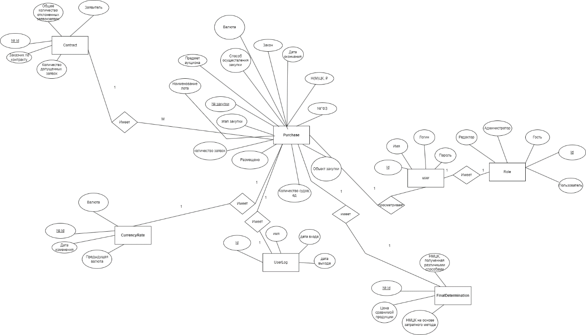
Диаграмма архитектуры приложения
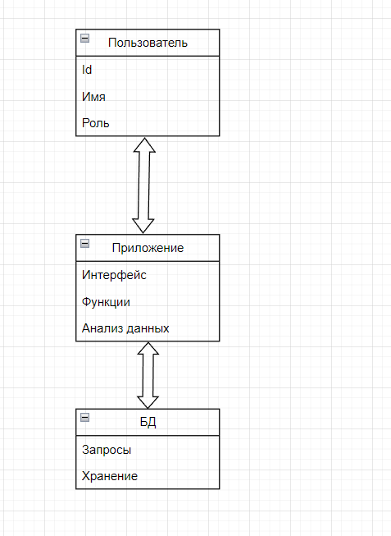
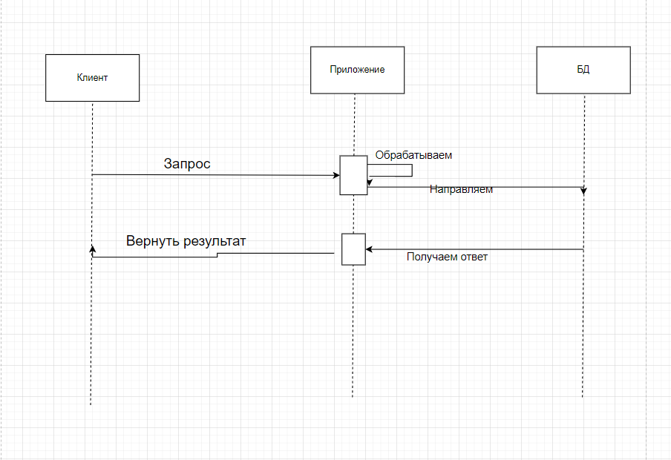
Таблица ролей
Роль | Просмотр БД | Использование фильтров | Загрузка данных в БД | Выгрузка Данных из БД | Редактирование БД | Управление пользователями,  БД
Администратор | Да | Да | Да | Да | Да | Да
Редактор | Да | Да | Да | Да | Да | Нет
Пользователь | Да | Да | Нет | Да | Нет | Нет
Гость | Да | Да | Нет | Нет | Нет | Нет

